Personal Health Dashboard

#### University of Utah Primary Children’s Hospital

Created by: WingKi Yu, Himmie Lau, Devansh Saxena

Date: 12/15/2023

# 

# 

# Table of Contents

Executive Summary________________________________________________________3

Project Overview__________________________________________________________4

Deliverables______________________________________________________________5

Data Cleaning_______________________________________________________5

Health Data Scoring System____________________________________________7

Health Dashboard____________________________________________________8

System Administration + Access control _________________________________12

Security Policies and Security Training___________________________________18

Incident Response___________________________________________________21  
Lessons Learned__________________________________________________________23

Future Implementation ____________________________________________________24

Reference _______________________________________________________________26

# 

# Executive Summary

Our project's goal was to develop an interactive health dashboard for the Pediatric Cardiology Dyslipidemia Clinic, aimed at enhancing patient and parent engagement in health management. We created a user-friendly, interactive dashboard that effectively visualizes patient health data, using the Life Essential 8 scoring system as the foundation. The dashboard integrates more than 100 data points, including ten de-identified patient data points from the clinic, meticulously processed and cleaned with Python.

We also built a custom calculator for the scoring system was developed and integrated into the dashboard, which was built using Tableau. This approach ensures a clear visual representation of complex patient data, enabling medical personnel to quickly understand and respond to patient needs. The dashboard also allows patients to monitor their progress over time, fostering engagement in their health management.

Security and confidentiality were paramount in our approach. We designed the dashboard with tailored access for three key user groups: health practitioners, administrators, data analysts, and patients. This stratification ensures the protection of sensitive patient data, building trust among all stakeholders and facilitating the dashboard's adoption.

Tableau Cloud was chosen for its security features, scalability, and user-friendly interface, accessible via the Tableau Mobile app. It offers built-in access controls, row-level security, reliable encryption, and reduced infrastructure costs. This selection underpins our commitment to ethical data handling and the effective management of increasing data volumes.

# 

# Project Overview

Project Objectives

The primary objective of our project was to transform the way the Pediatric Cardiology Dyslipidemia Clinic manages and utilizes patient data. Traditionally, patient data was collected physically and used primarily for research. Dr. Ware, a key figure in the clinic, emphasized the need for early identification of cardiovascular risks to significantly reduce the likelihood of heart diseases in the future.

Our project addressed a crucial gap: current methods of presenting health data were not engaging enough for young patients, leading to a lack of motivation and involvement in their health management. Additionally, it was essential to involve parents more effectively, ensuring they understood their child’s health journey. Inspired by Dr. Ware’s vision, our project aimed to make health data both accessible and understandable, enhancing patient care through improved data management and accessibility.

The clinic's previous approach to data collection was largely for research purposes. Our dashboard signifies a major advancement, shifting the focus from research to active patient care management. By making health data more accessible and engaging, the dashboard adds significant value to the clinic, enhancing patient engagement and empowering healthcare professionals with better tools for decision-making and patient counseling.

Team members and Roles

The project was led by Himmie Lau as the Project Manager, coordinating and overseeing the project’s progression. WingKi Yu, our Data Analyst, was instrumental in the collection, cleaning, and analysis of patient data. Devansh Saxena played a crucial role in Security Management, ensuring the data's safety and compliance with health privacy standards.

Approach

Our approach combined various technical and analytical methods. We used Python for data processing, emphasizing accuracy and relevance. The project was managed using agile methodologies, which allowed for flexibility and adaptability in our workflow. Communication was a cornerstone of our approach, maintaining transparency and collaboration among team members and stakeholders throughout the project lifecycle. The implementation of Tableau Cloud for the dashboard was a strategic choice, guided by its scalability, robust security features, and user-friendly interface. This technology not only met our immediate needs but also provided a sustainable, cost-effective solution for the clinic’s future data management requirements.

# Deliverables

**Types of Data**

Unlike data in business and other domains, there are established and defined standards for determining cardiovascular health. This simplifies and streamlines the development of a scoring system.

Dr. Ware envisions creating a system based on Life’s Essential 8, which are the key measures for improving and maintaining cardiovascular health, as defined by the American Heart Association. According to Life’s Essential 8, the components of cardiovascular health include a healthy diet, physical activity, avoidance of nicotine, healthy sleep patterns, maintaining a healthy weight, and healthy levels of blood lipids, blood glucose, and blood pressure. The lab collects data on patients' weight, blood lipid levels, blood glucose levels, and blood pressure when they visit the clinic. Additionally, the clinic uses a screener completed by the patients or their representatives, which measures the frequency of these behavioral factors. The combination of lab results and survey responses has proven to be a powerful tool for healthcare providers in assessing patients' health conditions.

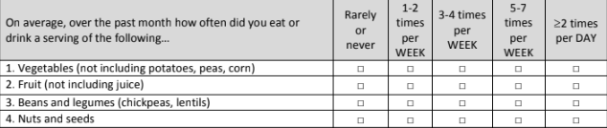

Figure 1: Example of Screener

**Data Cleaning**

Our team faced the most roadblocks in data cleaning in the entire project. First, data cleaning is the most time-consuming task. Secondly, we only had a little data to start with because the data currently collected in the clinic was physically collected.

After discussing this with the faculty advisor, Vandana Ramachandran, we decided to simulate 100 instances from the 10 data points we had to keep this project moving forward. To achieve this, we expanded our dataset by creating additional patient profiles. In total, we added eight new patients, and for each patient, we simulated 6 to 7 clinic survey data points. This approach provided us with a larger dataset. It allowed us to test our data-cleaning process on a more robust and varied set of data, closely mimicking real-world scenarios.

Once data was simulated, we immediately started cleaning and transformation using Python. We uploaded the codes to a public repository (for the purpose of this course) in Github. The codes can be reviewed through this link ([Link to Github Preview](https://github.com/yuwingki/Children-Hospital-Dashboard/blob/main/Pediatric%20-%20Data%20pipeline%20-%20Cleaning_indexes.ipynb)). Comments were made for better team collaboration and handoffs.

First, the data is read in the CSV format. Then, the data undergoes the cleaning and preprocessing stage, where it is refined to ensure consistency and accuracy. The process consists of:

* checking the structure of the data
* dropping unnecessary measurements that are not part of the calculation in the scoring system
* setting indexes
* renaming columns
* rearranging columns
* inserting values to handle missing values
* correcting values
* dummy encoding because the variables are not enumerated

Following data cleansing, the health scores are calculated using the rules in the scoring system.

The most difficult challenge to working with manual data entry or manual data simulation is that it can introduce many human errors into the dataset, for example, input errors, logical errors, incomplete data, non-random patterns, and data distribution errors. To address all of these errors, it took our team a longer time to complete the task, which introduced a new risk of delaying the delivery of the project. An unexpectedly massive amount of effort was needed to correct the errors found in the original or simulated datasets. Therefore, due to the time constraint and the extra steps to correct the unexpected errors, the compiled codes were done only to fulfill the requirements of this course. As a next step, they must be optimized from ingestion to storage into a data pipeline to ensure a streamlined and automated approach to handling large volumes of information, empowering the hospital to make practical consulting sessions based on accurate and timely data.

**Health Data Scoring System**

The scoring system is intended to show the cardiovascular health score of a patient based on the survey responses. According to the research we did on Life’s Essential 8, we could assign weights to the frequency options and to the measurements on the survey. Additionally, to avoid introducing complexity in the system, we broke the calculation into five different parts: a score based on healthy food intake, a score based on unhealthy food intake, a score based on physical activity level, a score based on sleeping hours, and a score based on the exposure to cigarettes. Based on the responses to the measurements in these areas, we could calculate the scores in the five areas and use the sum of the scores to obtain the final health score. A calculation demo can be viewed using this link ([Link to Calculator in Google Sheets](https://docs.google.com/spreadsheets/d/1yyz3KneZbg6iugVVcmKM6teOFR0-VpQN8N24iU97kh8/edit?usp=sharing)).



Figure 2: Example of Calculator

While reviewing the architecture of the calculator with Dr. Ware, we identified the variables that are not so important and can be dropped in the calculation. There is an opportunity to revise the survey as another incentive for the patients to be more engaged by shortening the survey.

After finalizing the architecture of the calculator, our team was able to set up the rules of the calculations using if-else functions in Python. The smoking score is the simplest example. When the system finds a value under the dummy column indicating exposure to smoking, the patient will not get any scores in the area. Meanwhile, when the system finds a value under the dummy column indicating an opposite observation, the patient will get a 100 in the smoking score.

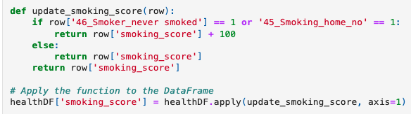

Figure 3: Example code of calculating the smoking score

In total, six scores will be assigned to each data line for analytics to derive valuable insights in the next step.

**The Mock-up Health Dashboard**

We had multiple visions for the choice of style and the type of graphs used in the health dashboard. Dr. Ware also provided examples of the desired type of graphs for data visualization. Combining our research and Dr. Ware’s references, we envisioned the dashboard to adopt a gaming scoreboard design using several gauge charts. We believed such a design could encourage more engagement from younger kids and teenagers. Unfortunately, the creation of gauge charts can be unexpectedly complicated in Tableau. There was no short-term solution to creating gauge charts, so instead, we focused on the business requirement to provide an intuitive dashboard interface and created four visualizations around the requirement.

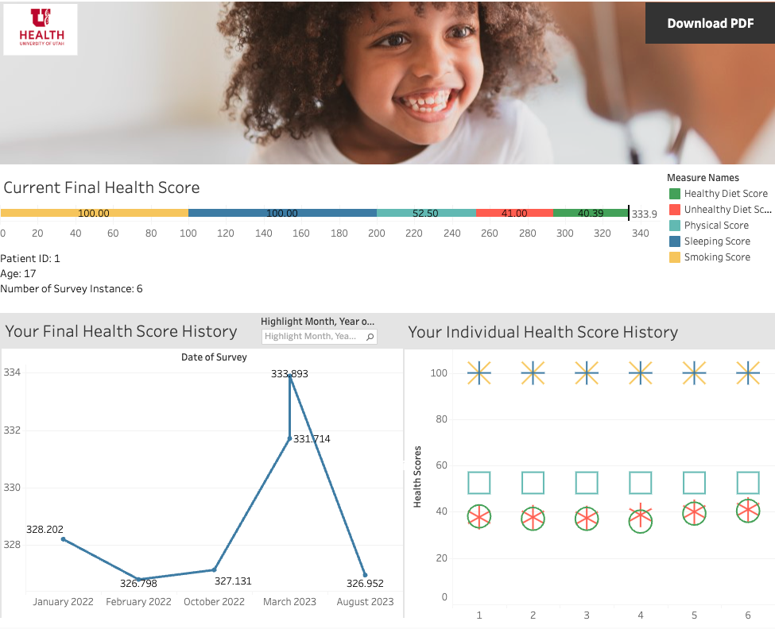

Figure 4: the overview of the mock-up dashboard created using simulated data of patient 1 in Tableau

The design of the mock-up dashboard is simple and intuitive because the target audiences are children with a range of ages from 8 to 18 and healthcare providers. However, a dashboard walkthrough will be highly recommended for first-time users.

Each dashboard is intended only to present the information and data from the patient with the same patient ID associated with the patient’s login credentials. Three visualizations are implemented in the dashboard to engage the target audiences.

First, a stacked bar chart (see Figure 5 below) is used to give the final health score for the latest entry as well as the composition of the five components that are represented by five different colors (healthy diet score, unhealthy diet score, physical score, sleeping score, and smoking score). The patients should be educated about the standard of the final health score (what will be considered a safe zone, an improvement-needed zone, and a danger zone) when the perfect health score is 400. This can also be an additional feature by adding a tooltip or having a message giving the interpretation of the final health score. When hovering over one component in the graph, a text box will show up with more details about that selected element (see Figure 6 below). This applies to all graphs in the dashboard.

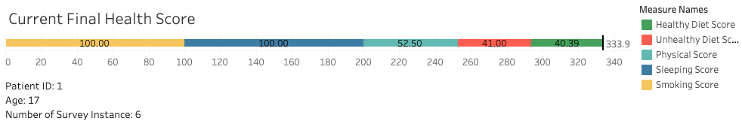

Figure 5: stacked bar chart showing the current final health score of patient 1 in the mock-up dashboard

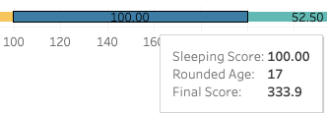

Figure 6: the hovering feature shows more details of the selected component in the scoring system

The second visualization (see Figure 7 below) is a line graph illustrating the patterns in the final health score over the whole time of all screeners filled out by patient 1’s party. The x-axis represents the passage of time in the month-year format, while the y-axis represents the final health score of each instance. In this example, the graph clearly shows that patient 1 needs a reminder to fill out the survey in any form to help the clinic and the patient understand their health condition. Although patient 1 is great at maintaining the final health score between 326 and 328, the most extended break is from February 2022 to October 2022. He/she can increase the score to the 331-to-333 range and enter the survey twice in March 2023, but we can see another slack-off after that until another entry in August 2023.

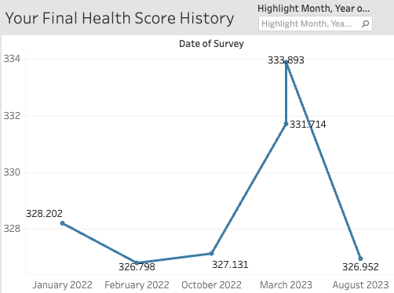

Figure 7: line graph showing the final health score history of patient 1 in the mock-up dashboard

Thirdly, the bar chart (see Figure 8 below) displays the trend of each component of the final health score across each screener entry. The color and the shape can differentiate each component of the final health score. The graph becomes extra helpful when it is read alongside the second visualization to investigate the patient's health condition better. For example, patient 1 maintains perfect scores in the area of sleeping and smoking environments. This indicates that patient one has been able to get sufficient sleep at his/her age of 17 while having minimal to no exposure to smoking. However, patient one has been obtaining the same physical activity score, i.e., 52.5, indicating that he/she has shown no effort in exercising more. Since the score for sleeping, smoking, and physical activity has remained consistent, we can conclude that the change in diet is the cause of the ups and downs.

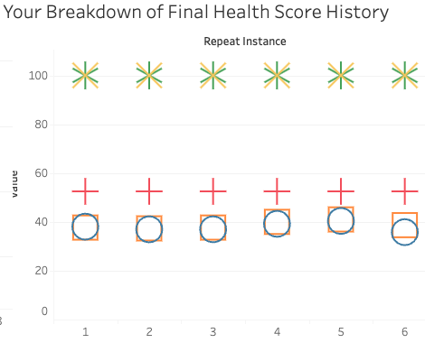

Figure 8: shape chart showing the trends of the components of the final health score of patient 1 in the mock-up dashboard

For the convenience of the healthcare providers, demographical and identifier information about the patient is contained in the dashboard (see Figure 9 below), including the patient ID, their rounded current age, and the number of the latest entry (or instance).



Figure 9: additional information on patient 1 in the mock-up dashboard

We should also mention that the banner photo (little African boy having heart listened to) is licensable; if not, it should be changed to a stock photo with appropriate copyright.

Ultimately, we delivered 4 KPIs, which is one less than what was listed on the SOW. However, we would like to maintain an intuitive and user-friendly dashboard interface. Therefore, balancing between ease of navigation and the amount of information, we decided to reduce the KPIs to 4. Most importantly, during our last meeting with Dr. Ware, he gave positive affirmations about the end product we had. A potential feature in the future is to incorporate patient’s lab results alongside the survey results.

**System Administration + Access control**

**Tableau Cloud Overview:**

We chose Tableau Cloud/Online to develop a Personal Health Dashboard for the Pediatric Cardiology Dyslipidemia Clinic as it comes with several advantages that align well with our current needs. Here are some reasons:

* Tableau Online is a cloud-based platform allowing users/patients to access dashboards and reports remotely with a secure connection.
* As the clinic grows or needs change, Tableau Online can scale to accommodate increased data volumes and additional users without requiring significant infrastructure adjustments.
* Tableau Online handles software updates and maintenance tasks automatically. This ensures that the clinic's pediatric health dashboard always runs the latest version without manual intervention, reducing the burden on IT staff.
* Tableau Online provides robust security features, including data encryption, user authentication, and access controls.
* Tableau Online is also HIPAA compliant and SOC II TYPE II certified.
* Tableau integrates seamlessly with various data sources, allowing us to pull data from electronic health records (EHRs), spreadsheets, databases, and other sources.
* Tableau offers an intuitive and user-friendly interface for building dashboards and reports.
* Tableau Online supports mobile access, enabling healthcare providers to view pediatric health dashboards on tablets or smartphones.
* Tableau Online eliminates the need for on-premises hardware and infrastructure, potentially reducing server maintenance and management costs.

**User and Group Management:**

* We have created multiple groups, such as Dashboard Administration, Data Analysts, Health Practitioners and Patients:
* An administrator can assign roles and permissions to users and groups by selecting permissions.

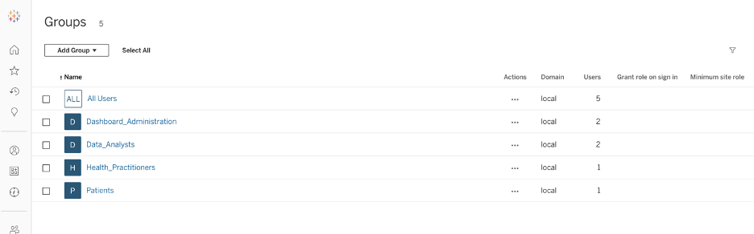

Figure 10: Tableau user groups

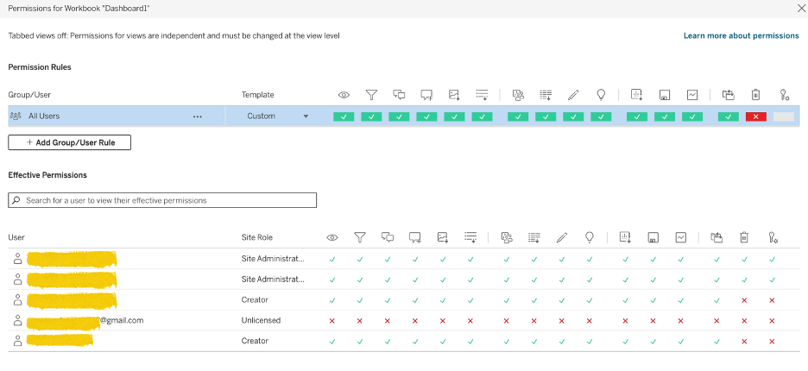

Figure 11: Setting Permissions for Users

**Access Control:**

* We have configured access control settings for workbooks and dashboards specific to patients, health practitioners, and data analysts.
* We also implemented row-level security for certain dashboards.

**Authentication**

* We have implemented MFA as an extra layer of security; users can choose their authentication type when registering for Tableau.
* We have not enabled Personal access tokens (PATs); these are long-lived authentication tokens that allow users to sign in to the Tableau REST API without requiring hard-coded credentials or interactive sign-in.

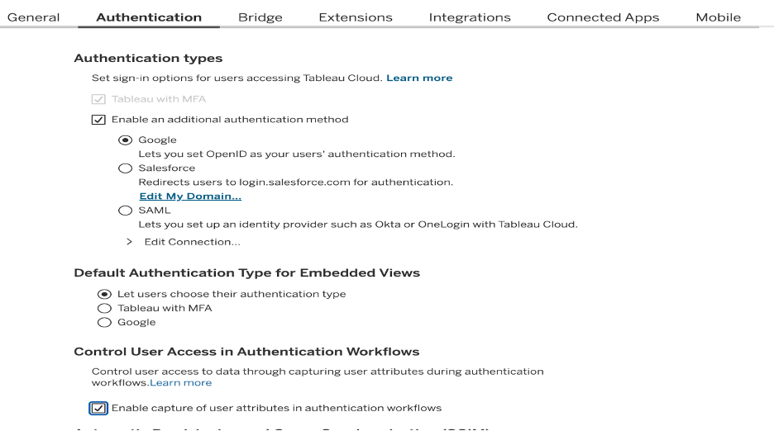

Figure 12: MFA implementation

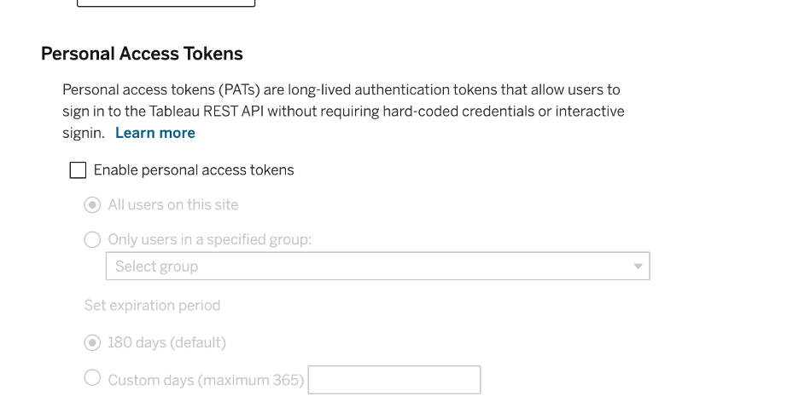

Figure 13: PAT setting

**Monitoring and Logging:**

* Monitoring server performance and resource utilization is an essential practice for any site administration. Tableau Online does not offer exclusive logging and monitoring capabilities; however, we have created personalized admin views to monitor the logging activity, traffic drill down, site content, and much more. Additionally, we have set admin insight update frequency to daily for better control.
* Any future administrator can tailor the admin view as per their needs and requirements.

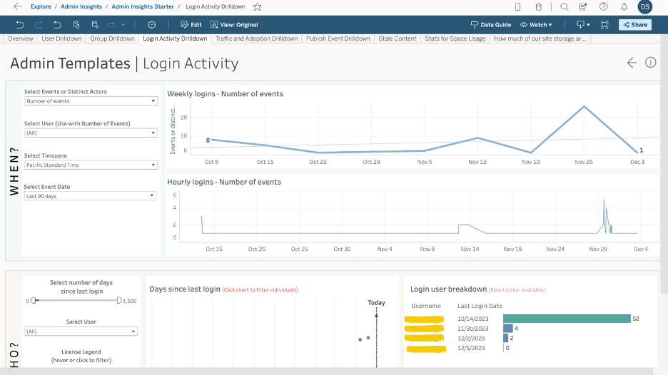

Figure 14: Admin View for Logging and Monitoring

**Secure Connection:**

* For data in transit, the connection is encrypted using TLS. In addition, Tableau has built-in security mechanisms to help prevent spoofing, hijacking, and SQL injection attacks.
* Passwords are stored using cryptographic protection. Tableau employees and contractors do not have access to plain-text passwords.
* Tableau Online uses Amazon EBS encryption by default, and all extracts are fully encrypted at the service level.

**Upgrades and Updates:**

* With Tableau Cloud, we are always on the latest, most-advanced version of Tableau.

**Set Time Zones for Extracts:**

* For future implementation, we have set the time zone for extract-based data sources to (UTC-07:00) America/Denver.
* Any administrator can change extract time to their requirements.

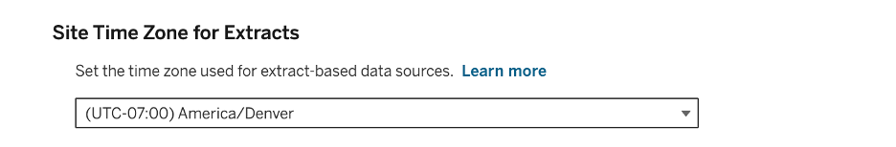

Figure 15: Setting Time Zone for Extracts

**Tableau Mobile Access:**

* We have enabled App Lock, which requires users to open the app with a biometric method or device passcode.
* We have enabled Offline previews, which let users see their start pages, favorite workbooks, and views when they’re not connected to the server.
* We have enabled Jailbreak Detection with a critical level, which wipes the data off the app and logs the user out.
* We have enabled Malware Detection (Android Only) with a critical level, which wipes the data off the app and logs the user out.
* A security policy refresh is performed when users open the app with an internet connection. We have enforced the maximum days offline without policy refresh to 14 days with a critical level.
* We have enabled the blocking of screen sharing and screenshots. (Android Only)

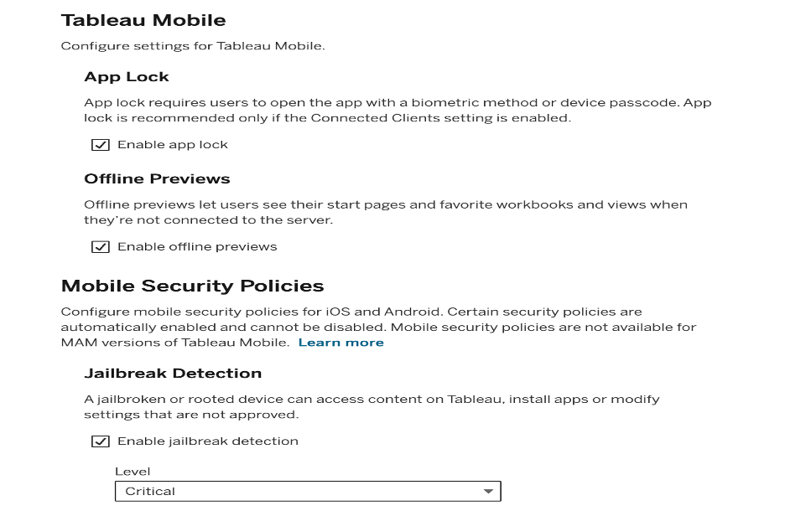

Figure 16: Tableau Mobile settings

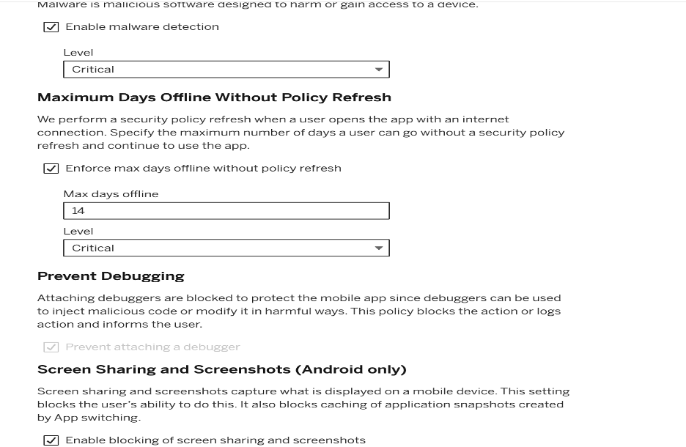

Figure 17: Tableau Mobile settings

**Future Implementation:**

* For future implementations, learning, and changing settings as per user/administrator basis, a site administrator can visit this site to understand and implement changes:

<https://help.tableau.com/current/online/en-us/to_get_started.htm>

**Security Policies**

**Account and Password Use:**

* Each team member must have a unique user account to access the health dashboard system.
* Passwords must adhere to established guidelines, including minimum length of 10 characters and a mix of characters (letters, numbers, symbols).
* Passwords must not be shared with anyone and should not be written down or stored in unsecured locations.
* All electronic communication must have a digital signature from the sender and receiver to ensure non-repudiation.
* Passwords should be changed every six months or immediately if there's any suspicion of being compromised.

**Remote Access and Security:**

* Accessing the health dashboard of any patient by a health practitioner from home or public computers is prohibited.
* All the patients should access their dashboards via the Tableau Mobile app.
* MFA has to be used by every single person accessing the dashboard; Personal Access Tokens for longer logins are prohibited.

**Handling of PHI:**

* Employees are not permitted to discuss PHI, even if the patient requests to have it removed from the office.
* PHI should not be printed for purposes other than medical review or to be sent to insurance companies.
* If an employee discloses any patient PHI, the appropriate course of action is to terminate them immediately and execute the IRP plan for recovery.
* When developing KPIs, data analysts should be provided with de-identified data to work with.
* Ensure that any digital patient data is accessed only through secure, authorized systems and not saved onto personal devices.

**Security Measures During Inactivity:**

* Always log off the health dashboard when not used, including during short breaks.
* The computers are set to automatically lock after a period of inactivity, requiring a password to regain access.
* Recommended lockout after 15 minutes of inactivity.

**Compliance and Reporting:**

* Ensure adherence to healthcare data security regulations and internal policies such as HIPAA and GDPR.
* Understand and follow the procedure for reporting any security incidents or suspected breaches.

**Vendor Management:**

* Vulnerability found within the Tableau cloud should be immediately reported to the vendor.
* Issues related to a data breach or data backup's should be reported to the vendor.
* Vulnerability assessment of vendor products is strictly prohibited, and no employee is allowed to conduct them.

**Devices in the Clinic:**

* The computers and tablets used to show patients their personal dashboards should not be used to visit external sites, download documents, or log in to personal accounts.
* These devices should have an internal firewall set to accept only secure connections to the Tableau Cloud. Any other activity is prohibited on them.
* No employee is allowed to change the Firewall, Antivirus, or Wifi settings on these devices.

**Network Segmentation:**

* Clinic employees and devices should be on a personal clinic network, which is separated from the public Wifi.
* The Clinic should have a separate public Wifi for the patients.
* No employee is allowed to use Clinics Public Wifi.
* Strict firewall rules are to be implemented for the Clinic's personal network.

**Other Concerns:**

* All the employees should be trained and informed about Phishing and Social Engineering Attacks.
* All the employees should be encouraged to provide any suspicious activity related to Insider Threats.
* In any scenario where sensitive information has been leaked, the IRP should be followed step by step.

### 

### 

### 

### **Security Training (Site Administrator, Health Practitioners and Data Analysts):**

**Data Handling and Privacy Training:**

Employees should be educated on handling patient data responsibly by training them on and about these topics:

* HIPAA and GDPR compliance.
* Principles of data de-identification and anonymization.
* Strict adherence to the Handling of PHI policy.

**Secure Dashboard Access Training:**

Employees should be instructed on securely accessing and navigating the health dashboard by training them on and about these topics:

* Multi-factor authentication best practices.
* Recognizing and reporting suspicious activities.
* Training them on Remote Access and Security policy and Devices in Clinic policy.

**Incident Response Training:**

Every employee should be effectively able to respond to security incidents. They must go through the Incident Response Plan and should be trained on these techniques:

* Recognizing security incidents and understanding Incident Response Plan procedures.
* Communication protocols during a security breach.

**Password Security Training:**

All the employees should be encouraged to follow strong password practices. They should be trained on the following topics:

* Creating and maintaining strong passwords.
* Importance of password confidentiality.
* Recognizing and reporting phishing and social engineering attempts.
* They should be trained on the Account and Password use policy.

**Continuous Learning and Updates:**

All the employees should be informed about evolving security threats. They should be trained on the following topics:

* Periodic updates on emerging security threats.
* Industry best practices for maintaining a secure environment.
* Feedback mechanisms for reporting potential vulnerabilities.
* They should go through the Clinic's security policies before joining and adhere to them.
* They should be regularly trained on Security Policies, Incident Response Plan, and Security Best Practices.

**Incident Response Plan**

We have developed this Incident Response Plan (IRP), which outlines the procedures and actions to be taken in case of a cybersecurity incident or breach related to developing and implementing the health dashboard. The goal is to effectively detect, respond to, contain, eradicate, and recover from security incidents while minimizing potential damage and ensuring compliance.

**Before the Cybersecurity Incident**

**Train the users on the current Security policy:**

All the users and staff need to understand their role in maintaining and improving the security posture of the clinic. For this, they should be trained on security policies on a Bi-Annual basis.

**Create Incident Categories:**

Categorize potential security incidents such as:

* Unauthorized access to patient data.
* Data breaches and loss
* System vulnerabilities and exploits.
* Malicious activities affecting the dashboard's functionality.

**Create an Incident Response Team:**

Establish a dedicated Incident Response Team (IRT) consisting of individuals with expertise in cybersecurity, data protection, and relevant technical areas. Responsibilities should be clearly defined, and team members should be available for immediate response.

**Create Incident Reporting mechanism:**

Define a clear reporting structure for team members to report any suspicious activities or incidents promptly.

**During the Cybersecurity Incident**

**Incident Detection:**

When monitoring tools and systems detect unusual activities, unauthorized access, or a security incident. Analyze and categorize the incident and ensure that stakeholders and relevant authorities are notified.

**Assign Roles**:

* Appoint an Incident Manager (IM): They will take the lead in the response that follows. They will assign responsibilities and oversee communication channels.
* Assign Tech Manager (TM): This individual will be the subject matter expert. They will bring in additional internal and potentially external technological specialists.
* Appoint a Communications Manager (CM). This individual will interact with reporters, publish social media updates, and may interact with external stakeholders.

**Incident Response Steps**

**Initial Assessment:**

* Identify the nature and scope of the incident and determine the potential impact on patient data and system integrity.
* Record and assign incident severity levels.

**Containment:**

* Isolate affected systems, user devices, and accounts to prevent further damage.
* Limit access to sensitive data.

**Eradication:**

* Identify and eliminate the root cause of the incident.
* Patch vulnerabilities in the system and notify the vendor about the vulnerability.

**Recovery:**

* Restore affected systems to a secure state and ensure system functionality.
* Verify data confidentiality, integrity, and availability.
* Implement measures to prevent similar incidents in the future.

**After the Cybersecurity Incident**

**Documentation:**

Maintain detailed records of the incident, including the timeline of events, actions taken, and outcomes for post-incident analysis.

**Review and Lessons Learned:**

Conduct a thorough review of the incident response process after each security incident. Identify areas for improvement, update procedures accordingly, and provide additional training if necessary.

**Communication:**

Notify relevant stakeholders, including healthcare practitioners and patients, about the incident. Comply with legal obligations for data breach notifications.

# 

# Lessons Learned

Through the course of our project, our team gleaned several valuable insights from personal, managerial, and technical perspectives:

1. The Importance of Data Analytics and Cleaning

A significant learning point was the crucial role of data analytics and cleaning in processing raw data. Initially underestimated, we found that this process was the most time-consuming, necessitating regular objective realignments with stakeholders. This experience underscored the importance of continuous communication to ensure everyone involved was aligned and informed.

1. Bridging Technical and Non-Technical Gaps

Another challenge we faced was effectively communicating complex technical details to non-technical stakeholders. Many team members initially struggled with this aspect. Over time, we learned to simplify our language and employ relatable analogies, leading to clearer and more effective communication. This not only improved understanding but also fostered better collaboration between different groups within the project.

1. Data Management and Accessibility

We also encountered challenges related to data accessibility. Much of the necessary data was either not readily available or required manual input, which proved to be a significant time sink. This hurdle brought to light the essential nature of efficient data management in our field. It prompted us to seek more streamlined methods for data collection and utilization, enhancing our overall workflow and efficiency.

1. The Value of Flexibility and Backup Plans

Lastly, our project taught us the importance of adaptability and having contingency plans. Despite thorough planning, we faced unexpected challenges that rendered some of our initial strategies ineffective. These situations demanded quick thinking and the ability to pivot to alternative solutions. This aspect of the project was a potent reminder of the importance of flexibility and problem-solving in any professional endeavor.

# Future Implementation

We look forward to the next stages of this project. As we continue to consult with Dr. Ware about his vision for the project, we’ve identified several key steps to maximize the utility of our deliverables and to further enhance the dashboard.

1. Refinement of Survey Questions

A critical step involves refining our survey questions to enhance their clarity and relevance to health outcomes. Some of the current questions lack directness in terms of their impact on health. By redesigning these questions and possibly incorporating a scoring system, we aim to make the survey more effective and insightful for both respondents and analysts.

1. Digitalization of the Survey Process

Moving forward, we plan to digitalize our survey using REDcap. This transition will not only streamline the survey process but also ensure greater data accuracy and security. By adopting a digital platform, we can facilitate easier access and completion of the survey, thereby increasing participation rates and the reliability of the data collected.

1. Development of Comprehensive Data Storage

Another key objective is to create a comprehensive data storage system specifically for our survey data. This will involve establishing a structured and secure repository that allows for efficient data management and retrieval, which is essential for ongoing analysis and reporting.

1. Integration of Lab Results with Survey Data

In response to feedback from Dr. Ware, we aim to integrate laboratory results with survey data on our dashboard. This integration will enable a more holistic view of patient health, allowing the data to 'speak' more effectively and provide deeper insights into health trends and outcomes.

1. Dashboard Implementation Across Multiple Clinics

Finally, a major goal is to implement our dashboard across multiple clinics. Expanding the use of our dashboard will enable more healthcare providers to leverage this tool for enhanced patient care. By making it accessible to a wider range of clinics, we can contribute to better health management and outcomes on a broader scale.

# Reference

<https://help.tableau.com/current/online/en-us/to_get_started.htm> accessed on December 15, 2023.

<https://www.cisa.gov/sites/default/files/publications/Incident-Response-Plan-Basics_508c.pdf> accessed on December 15, 2023.